DATABASE MANAGEMENT SYSTEM
CAPSTONE PROJECT
Aryan_2401010005
Btech cse
✈ Flight Reservation System

✈ Project Description — Flight Reservation System

This project focuses on designing and implementing a relational database system for a Flight Reservation System using MySQL. The system models core entities involved in airline operations, including airports, airlines, routes, flights, passengers, bookings, seats, payments, loyalty programs, and fare classes. Each table is designed with appropriate primary keys, foreign keys, and constraints to maintain data integrity and establish clear relationships between the components of the reservation system.

SQL queries are implemented to handle essential operations such as managing seat availability and booking status, processing flight cancellations, handling overbooking situations, prioritizing passenger upgrades based on fare class or loyalty tier, and generating payment records. These queries help minimize scheduling conflicts, automate upgrade decisions, and ensure accurate revenue tracking across flights.

The project demonstrates how a well-structured relational database can power a production-grade flight reservation platform — enabling real-time seat management, loyalty program integration, and seamless passenger experience from booking to boarding.

✈ Key Objectives

- Design a schema to store flight information including routes, schedules, and seat capacities
- Implement queries to handle seat availability, booking status, and flight cancellations
- Handle overbooking situations and prioritize passenger upgrades based on loyalty programs or fare classes
- Track payment records, refund statuses, and generate billing summaries per booking
- Manage passenger profiles and link them to loyalty reward points and tier levels
- Support multi-leg journey bookings with layover information across routes

✈ Project Information

Project Title | Flight Reservation System
Technology | MySQL (Relational Database)
Domain | Airlines / Travel Management
Key Entities | Airports, Airlines, Flights, Routes, Passengers, Bookings, Seats, Payments, Loyalty Programs, Fare Classes
Core Features | Seat booking, Overbooking management, Fare class upgrades, Loyalty points, Cancellations & Refunds

✈ Database Schema Overview

Table | Key Columns
Airports | airport_id (PK), airport_code, name, city, country
Airlines | airline_id (PK), airline_name, iata_code, country
Routes | route_id (PK), origin_airport_id (FK), destination_airport_id (FK), distance_km
Flights | flight_id (PK), airline_id (FK), route_id (FK), departure_time, arrival_time, status, total_seats
Passengers | passenger_id (PK), full_name, email, phone, passport_no, nationality
Fare_Classes | fare_class_id (PK), class_name (Economy/Business/First), base_multiplier
Seats | seat_id (PK), flight_id (FK), seat_number, fare_class_id (FK), status (Available/Booked/Reserved)
Bookings | booking_id (PK), passenger_id (FK), seat_id (FK), flight_id (FK), booking_date, booking_status
Payments | payment_id (PK), booking_id (FK), amount, payment_status, payment_method, payment_date
Loyalty_Programs | loyalty_id (PK), passenger_id (FK), tier (Bronze/Silver/Gold), points_balance
Cancellations | cancellation_id (PK), booking_id (FK), reason, refund_status, cancelled_at

✈ CODE

✈ CREATE DATABASE

CREATE DATABASE FlightReservationDB;
USE FlightReservationDB;

✈ CREATE TABLE

✈ Airports Table

CREATE TABLE Airports (
airport_id INT AUTO_INCREMENT PRIMARY KEY,
airport_code VARCHAR(10) NOT NULL UNIQUE,
name VARCHAR(100) NOT NULL,
city VARCHAR(60) NOT NULL,
country VARCHAR(60) NOT NULL
);

✈ Airlines Table

CREATE TABLE Airlines (
airline_id INT AUTO_INCREMENT PRIMARY KEY,
airline_name VARCHAR(100) NOT NULL,
iata_code VARCHAR(5) NOT NULL UNIQUE,
country VARCHAR(60)
);

✈ Routes Table

CREATE TABLE Routes (
route_id INT AUTO_INCREMENT PRIMARY KEY,
origin_airport_id INT NOT NULL,
destination_airport_id INT NOT NULL,
distance_km DECIMAL(8,2),
FOREIGN KEY (origin_airport_id) REFERENCES Airports(airport_id),
FOREIGN KEY (destination_airport_id) REFERENCES Airports(airport_id)
);

✈ Flights Table

CREATE TABLE Flights (
flight_id INT AUTO_INCREMENT PRIMARY KEY,
airline_id INT NOT NULL,
route_id INT NOT NULL,
flight_number VARCHAR(15) NOT NULL UNIQUE,
departure_time DATETIME NOT NULL,
arrival_time DATETIME NOT NULL,
total_seats INT NOT NULL DEFAULT 180,
status ENUM('Scheduled','Delayed','Cancelled','Completed') DEFAULT 'Scheduled',
FOREIGN KEY (airline_id) REFERENCES Airlines(airline_id),
FOREIGN KEY (route_id) REFERENCES Routes(route_id)
);

✈ Passengers Table

CREATE TABLE Passengers (
passenger_id INT AUTO_INCREMENT PRIMARY KEY,
full_name VARCHAR(100) NOT NULL,
email VARCHAR(100) UNIQUE NOT NULL,
phone VARCHAR(20),
passport_no VARCHAR(20) UNIQUE,
nationality VARCHAR(60),
date_of_birth DATE
);

✈ Fare_Classes Table

CREATE TABLE Fare_Classes (
fare_class_id INT AUTO_INCREMENT PRIMARY KEY,
class_name ENUM('Economy','Business','First') NOT NULL,
base_multiplier DECIMAL(4,2) DEFAULT 1.00
);

✈ Seats Table

CREATE TABLE Seats (
seat_id INT AUTO_INCREMENT PRIMARY KEY,
flight_id INT NOT NULL,
seat_number VARCHAR(5) NOT NULL,
fare_class_id INT NOT NULL,
status ENUM('Available','Booked','Reserved') DEFAULT 'Available',
FOREIGN KEY (flight_id) REFERENCES Flights(flight_id),
FOREIGN KEY (fare_class_id) REFERENCES Fare_Classes(fare_class_id)
);

✈ Bookings Table

CREATE TABLE Bookings (
booking_id INT AUTO_INCREMENT PRIMARY KEY,
passenger_id INT NOT NULL,
seat_id INT NOT NULL,
flight_id INT NOT NULL,
booking_date DATETIME DEFAULT CURRENT_TIMESTAMP,
booking_status ENUM('Confirmed','Pending','Cancelled','Waitlisted') DEFAULT 'Pending',
FOREIGN KEY (passenger_id) REFERENCES Passengers(passenger_id),
FOREIGN KEY (seat_id) REFERENCES Seats(seat_id),
FOREIGN KEY (flight_id) REFERENCES Flights(flight_id)
);

✈ Payments Table

CREATE TABLE Payments (
payment_id INT AUTO_INCREMENT PRIMARY KEY,
booking_id INT NOT NULL,
amount DECIMAL(10,2) NOT NULL,
payment_method ENUM('CreditCard','DebitCard','NetBanking','UPI','Wallet') NOT NULL,
payment_status ENUM('Paid','Pending','Refunded','Failed') DEFAULT 'Pending',
payment_date DATETIME DEFAULT CURRENT_TIMESTAMP,
FOREIGN KEY (booking_id) REFERENCES Bookings(booking_id)
);

✈ Loyalty_Programs Table

CREATE TABLE Loyalty_Programs (
loyalty_id INT AUTO_INCREMENT PRIMARY KEY,
passenger_id INT NOT NULL UNIQUE,
tier ENUM('Bronze','Silver','Gold','Platinum') DEFAULT 'Bronze',
points_balance INT DEFAULT 0,
enrolled_date DATE DEFAULT (CURDATE()),
FOREIGN KEY (passenger_id) REFERENCES Passengers(passenger_id)
);

✈ Cancellations Table

CREATE TABLE Cancellations (
cancellation_id INT AUTO_INCREMENT PRIMARY KEY,
booking_id INT NOT NULL,
reason TEXT,
refund_status ENUM('Pending','Processed','Denied') DEFAULT 'Pending',
cancelled_at DATETIME DEFAULT CURRENT_TIMESTAMP,
FOREIGN KEY (booking_id) REFERENCES Bookings(booking_id)
);

✈ INSERTION OF SAMPLE DATA

✈ Insert Airports

INSERT INTO Airports (airport_code, name, city, country) VALUES
('DEL', 'Indira Gandhi International', 'New Delhi', 'India'),
('BOM', 'Chhatrapati Shivaji Maharaj International', 'Mumbai', 'India'),
('DXB', 'Dubai International', 'Dubai', 'UAE'),
('LHR', 'Heathrow Airport', 'London', 'UK'),
('JFK', 'John F. Kennedy International', 'New York', 'USA');

✈ Insert Airlines

INSERT INTO Airlines (airline_name, iata_code, country) VALUES
('Air India', 'AI', 'India'),
('IndiGo', '6E', 'India'),
('Emirates', 'EK', 'UAE'),
('British Airways', 'BA', 'UK');

✈ Insert Fare Classes

INSERT INTO Fare_Classes (class_name, base_multiplier) VALUES
('Economy', 1.00),
('Business', 2.50),
('First', 4.00);

✈ Insert Passengers

INSERT INTO Passengers (full_name, email, phone, passport_no, nationality) VALUES
('Aarav Sharma', 'aarav@email.com', '9876543210', 'P1234567', 'Indian'),
('Priya Mehta', 'priya@email.com', '9123456789', 'P2345678', 'Indian'),
('John Smith', 'john@email.com', '+447911123456', 'GB9876543', 'British'),
('Fatima Al-Hassan', 'fatima@email.com', '+971501234567', 'AE3456789', 'Emirati'),
('Chen Wei', 'chenwei@email.com', '+8613012345678', 'CN4567890', 'Chinese');

✈ Insert Bookings & Payments

INSERT INTO Bookings (passenger_id, seat_id, flight_id, booking_status) VALUES
(1, 1, 1, 'Confirmed'),
(2, 5, 1, 'Confirmed'),
(3, 9, 2, 'Waitlisted'),
(4, 13, 2, 'Confirmed'),
(5, 17, 3, 'Cancelled');
INSERT INTO Payments (booking_id, amount, payment_method, payment_status) VALUES
(1, 8500.00, 'CreditCard', 'Paid'),
(2, 8500.00, 'UPI', 'Paid'),
(3, 21250.00, 'NetBanking', 'Pending'),
(4, 34000.00, 'CreditCard', 'Paid'),
(5, 0.00, 'Wallet', 'Refunded');

✈ Insert Loyalty Programs

INSERT INTO Loyalty_Programs (passenger_id, tier, points_balance) VALUES
(1, 'Gold', 15000),
(2, 'Silver', 7500),
(3, 'Platinum', 42000),
(4, 'Bronze', 1200),
(5, 'Gold', 18500);

✈ QUERIES

✈ View All Scheduled Flights

SELECT f.flight_id, f.flight_number, al.airline_name,
a1.city AS origin, a2.city AS destination,
f.departure_time, f.arrival_time, f.status
FROM Flights f
JOIN Airlines al ON f.airline_id = al.airline_id
JOIN Routes r ON f.route_id = r.route_id
JOIN Airports a1 ON r.origin_airport_id = a1.airport_id
JOIN Airports a2 ON r.destination_airport_id = a2.airport_id
WHERE f.status = 'Scheduled';
OUTPUT:
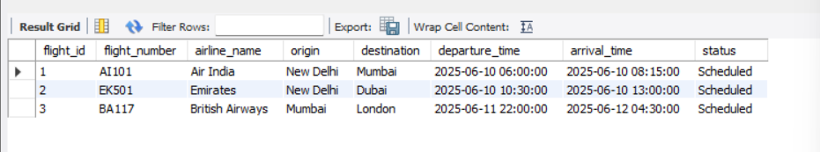

✈ Check Available Seats on a Flight

SELECT s.seat_number, fc.class_name, s.status
FROM Seats s
JOIN Fare_Classes fc ON s.fare_class_id = fc.fare_class_id
WHERE s.flight_id = 1 AND s.status = 'Available'
ORDER BY fc.class_name, s.seat_number;
OUTPUT:
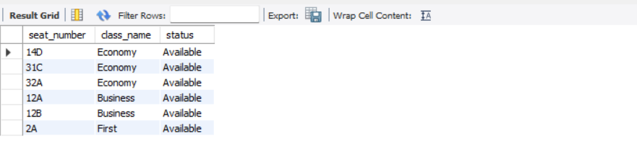

✈ Passenger Booking Status

SELECT b.booking_id, p.full_name, f.flight_number,
s.seat_number, fc.class_name, b.booking_status, b.booking_date
FROM Bookings b
JOIN Passengers p ON b.passenger_id = p.passenger_id
JOIN Flights f ON b.flight_id = f.flight_id
JOIN Seats s ON b.seat_id = s.seat_id
JOIN Fare_Classes fc ON s.fare_class_id = fc.fare_class_id;
OUTPUT:
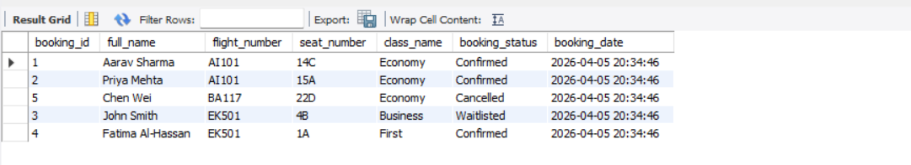

✈ Payment Records

SELECT p.full_name, f.flight_number, py.amount,
py.payment_method, py.payment_status, py.payment_date
FROM Payments py
JOIN Bookings b ON py.booking_id = b.booking_id
JOIN Passengers p ON b.passenger_id = p.passenger_id
JOIN Flights f ON b.flight_id = f.flight_id;
OUTPUT:
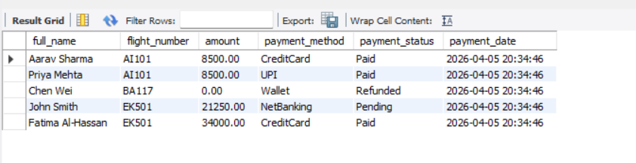

✈ Overbooking — Waitlisted Passengers

SELECT p.full_name, f.flight_number, b.booking_id,
lp.tier AS loyalty_tier, lp.points_balance
FROM Bookings b
JOIN Passengers p ON b.passenger_id = p.passenger_id
JOIN Flights f ON b.flight_id = f.flight_id
LEFT JOIN Loyalty_Programs lp ON p.passenger_id = lp.passenger_id
WHERE b.booking_status = 'Waitlisted'
ORDER BY lp.tier DESC, lp.points_balance DESC;
OUTPUT:
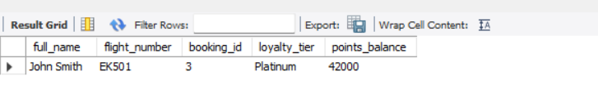

✈ Cancellations and Refund Status

SELECT p.full_name, f.flight_number, c.reason,
c.refund_status, c.cancelled_at
FROM Cancellations c
JOIN Bookings b ON c.booking_id = b.booking_id
JOIN Passengers p ON b.passenger_id = p.passenger_id
JOIN Flights f ON b.flight_id = f.flight_id;
OUTPUT:
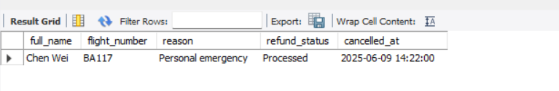

✈ Total Revenue per Flight

SELECT f.flight_number, al.airline_name,
COUNT(b.booking_id) AS total_bookings,
SUM(py.amount) AS total_revenue
FROM Flights f
JOIN Airlines al ON f.airline_id = al.airline_id
JOIN Bookings b ON f.flight_id = b.flight_id
JOIN Payments py ON b.booking_id = py.booking_id
WHERE py.payment_status = 'Paid'
GROUP BY f.flight_number, al.airline_name
ORDER BY total_revenue DESC;
OUTPUT:
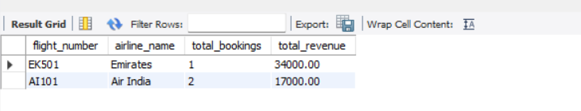

✈ Flight Load Factor (Seat Occupancy %)

SELECT f.flight_number,
f.total_seats,
COUNT(CASE WHEN s.status = 'Booked' THEN 1 END) AS booked_seats,
ROUND(COUNT(CASE WHEN s.status = 'Booked' THEN 1 END)
* 100.0 / f.total_seats, 2) AS load_factor_pct
FROM Flights f
LEFT JOIN Seats s ON f.flight_id = s.flight_id
GROUP BY f.flight_id, f.flight_number, f.total_seats;
OUTPUT:
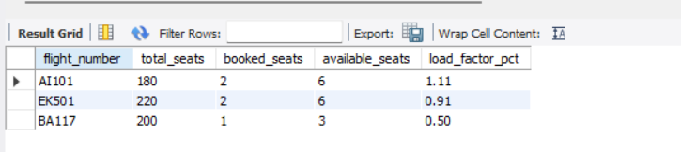

✈ Pending Payments

SELECT p.full_name, f.flight_number,
py.amount, py.payment_method, py.payment_date
FROM Payments py
JOIN Bookings b ON py.booking_id = b.booking_id
JOIN Passengers p ON b.passenger_id = p.passenger_id
JOIN Flights f ON b.flight_id = f.flight_id
WHERE py.payment_status = 'Pending';
OUTPUT:
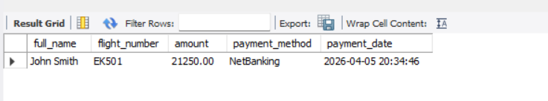
✈ Full Reservation Report

SELECT p.full_name, p.passport_no, f.flight_number,
a1.city AS from_city, a2.city AS to_city,
s.seat_number, fc.class_name,
b.booking_status, py.amount, py.payment_status,
lp.tier AS loyalty_tier
FROM Bookings b
JOIN Passengers p ON b.passenger_id = p.passenger_id
JOIN Flights f ON b.flight_id = f.flight_id
JOIN Routes r ON f.route_id = r.route_id
JOIN Airports a1 ON r.origin_airport_id = a1.airport_id
JOIN Airports a2 ON r.destination_airport_id = a2.airport_id
JOIN Seats s ON b.seat_id = s.seat_id
JOIN Fare_Classes fc ON s.fare_class_id = fc.fare_class_id
LEFT JOIN Payments py ON b.booking_id = py.booking_id
LEFT JOIN Loyalty_Programs lp ON p.passenger_id = lp.passenger_id;
OUTPUT:
